**IS LAB**

**Assignment 1**

**By:**

**SAARAM HUSSNAIN**

**SP24-BSE-011**

**Submitted to:**

**MAM. Ambreen Gul**

**Department of Computer Science**

COMSATS University Islamabad,

Attock Campus

**Study Salsa20 Cipher and do the following activity.**

1. Write python code for your designed stream cipher approach for encryption decryption, you can use approach from more than one already developed ciphers as given in lab practice exercises.

2. Design and implement an adversarial attack approach for your proposed stream cipher approach.

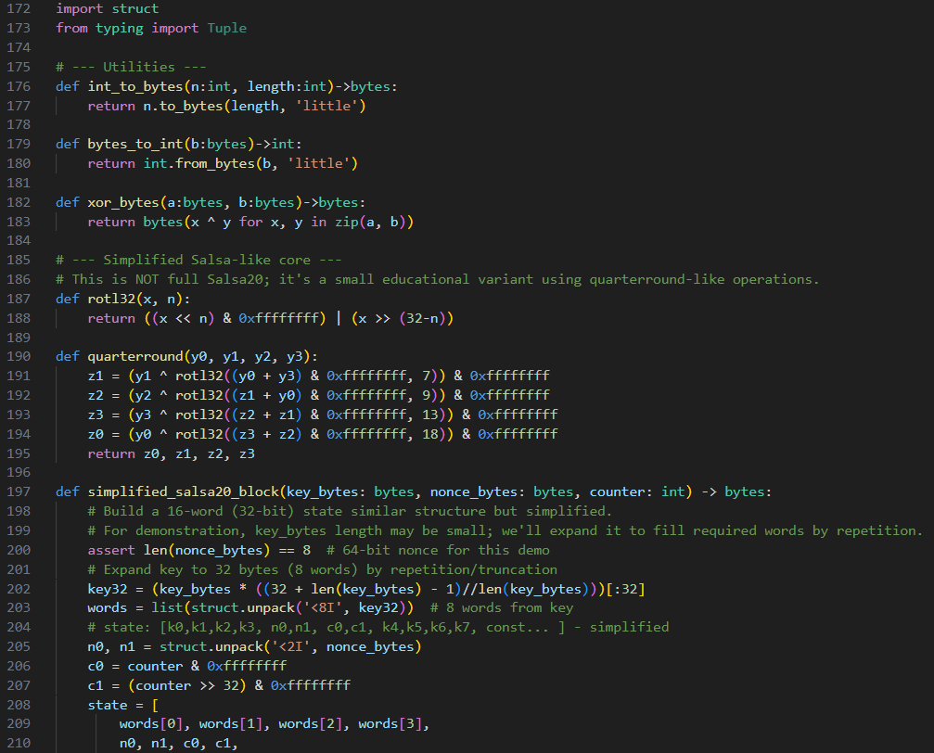

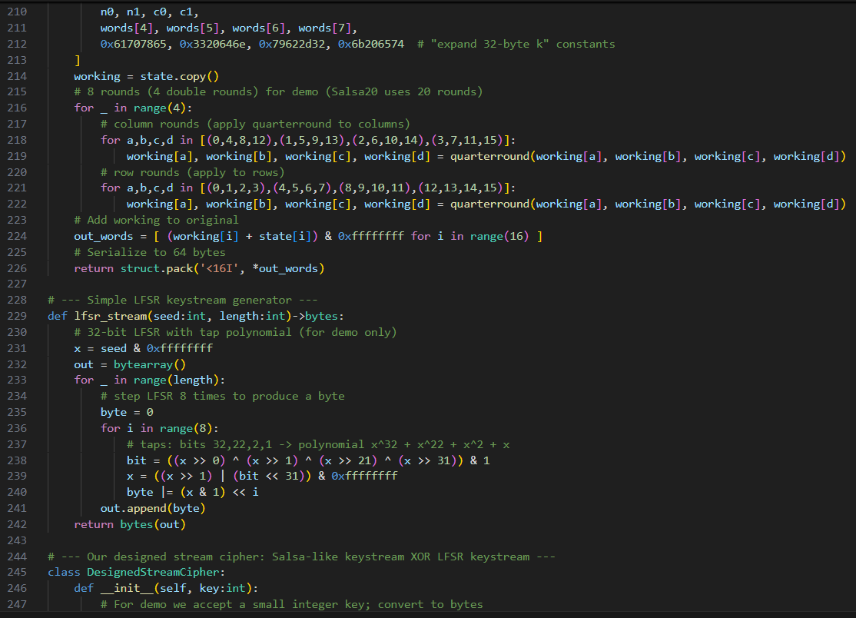

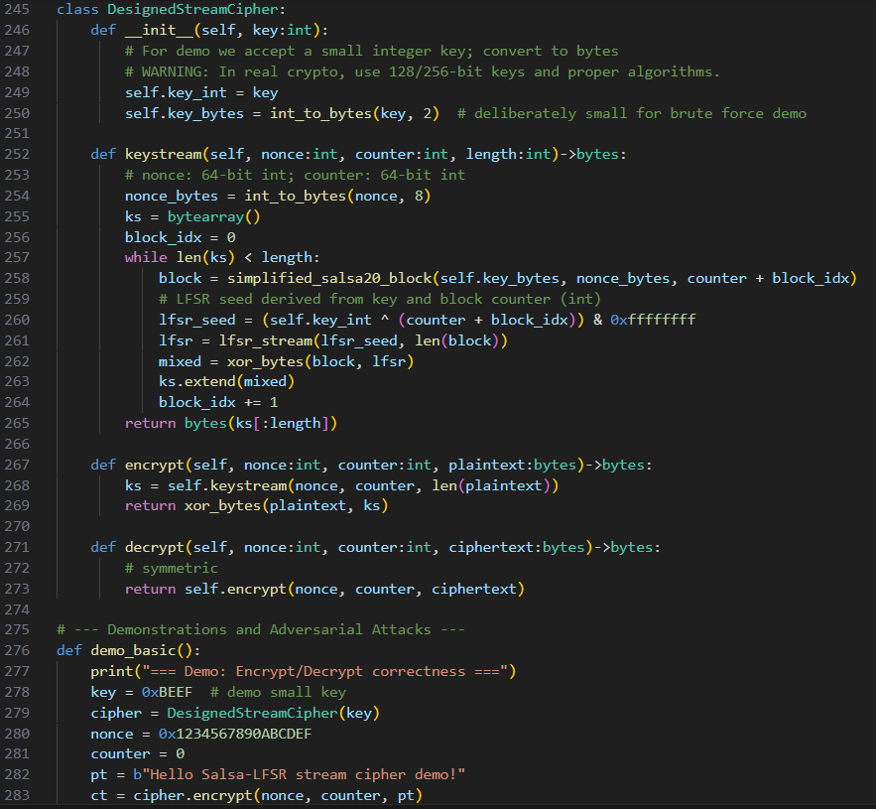

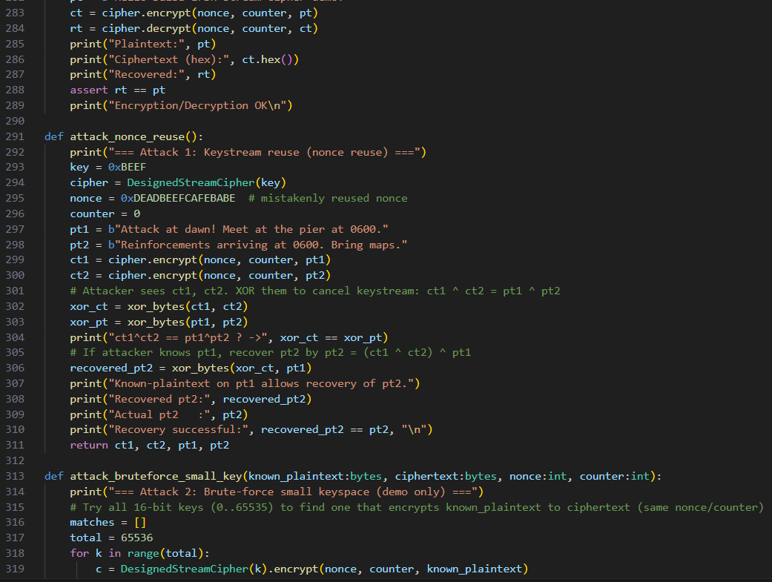

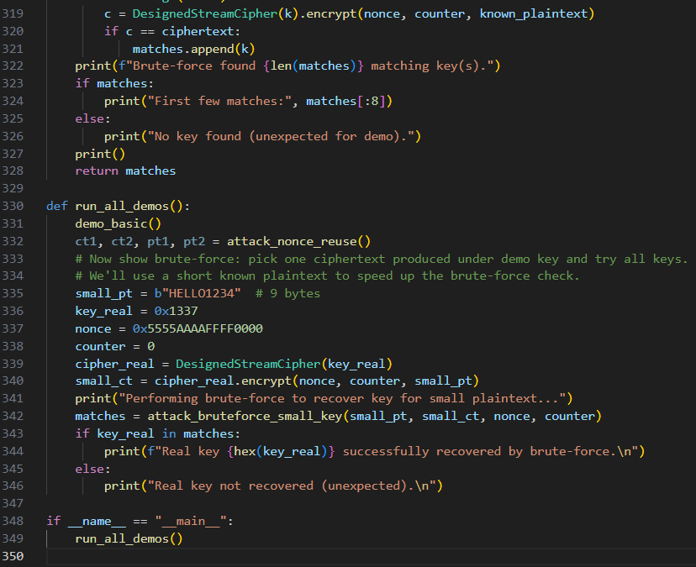

**OUTPUT:**

